**W02 Assignment: Team Project**

During our meeting, we discussed the following topics:

* Purpose of the project
* Fonts, layout, colors and styles
* Possible assignations for the project
* User stories

**URL** to the repo: <https://github.com/nicolasdfoti/handcrafted-haven/settings/access>

**Styles**:

Fonts:

* Poppins
* Playfair Display
* Epunda Slab

Colors:

* Header:
* #f1ece5

* Background:
* #9ba78d
* Main Background Gradient
* #D2B48C
* #C4A77E
* #B69A70
* #A88D62
* #9A8054

Work items:

1. User Registration and Authentication  
   As a new user, I want to create an account and log in securely so that I can access personalized features such as saving favorites and leaving reviews.
2. Seller Profile Creation  
   As an artisan, I want to create and edit my seller profile with a bio, profile photo, and contact information so that customers can learn more about me and my work.
3. Add New Product Listing  
   As a seller, I want to add new handcrafted products with images, prices, descriptions, and categories so that customers can browse and purchase them.
4. Browse Products Catalog  
   As a customer, I want to see a home page with available products in a clean and organized catalog view so that I can explore the store easily.
5. Filter and Search Products  
   As a customer, I want to search products by keywords and filter them by category or price range so that I can quickly find what I’m looking for.
6. Product Details Page  
   As a customer, I want to click on a product to view its full details, including images, seller info, and description, so that I can decide if I want to buy it.
7. Leave Product Review and Rating  
   As a customer, I want to leave a star rating and a short written review on products I’ve purchased so that other customers can see my feedback.
8. Responsive Design Implementation  
   As a user, I want the website layout to adapt to any screen size so that I can use it comfortably on mobile, tablet, or desktop devices.
9. Basic Shopping Cart System  
   As a customer, I want to add products to a cart and view them together so that I can review and manage my selections before checkout.
10. Deploy to Vercel  
    As a developer, I want to deploy our web app to Vercel so that our team and instructor can access it online and test its functionality.

**Screenshots**:

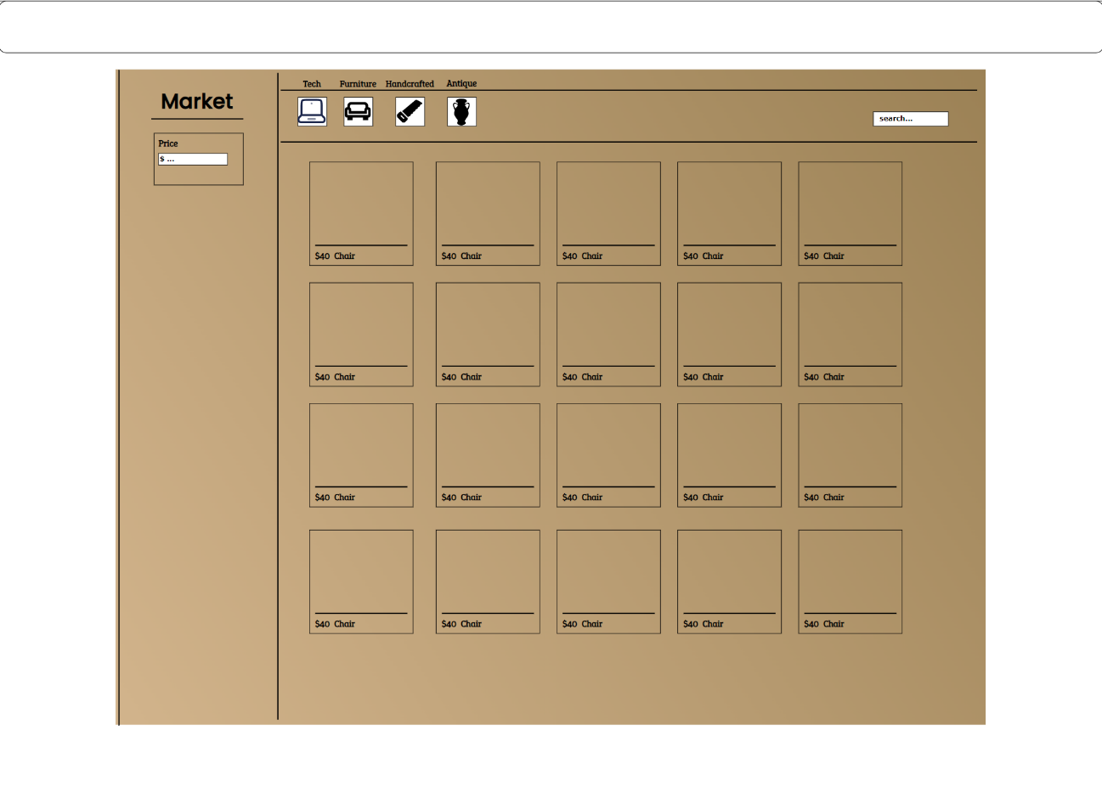

**Work items**:

